**Guided Capstone Project Report:**

**Context and Problem Identification**:

After recently adding a chairlift that increased operations costs by $1.5 million, *Big Mountain Resort* (BMR) wanted to re-evaluate its ticket pricing strategy based on data as it has suspected for quite a while it may be undercharging its guests for the offerings it currently possesses. This led to the following question: How can *BMR* adapt its ticket pricing strategy by capturing the full value of its diverse infrastructure, product, and natural offerings relative to its competitors to increase profitability by ~$3 million ?

**Data Cleaning & Exploratory Data Analysis (EDA):**

The data provided for this analysis contained information on 27 different parameters ~for 330 ski stations spread across >30 states. A quick glance at the data showed BMR currently charges above the current market average of weekend ticket prices of $64 with a price of $81. After wrangling and cleaning our data, we altered some parameters and were left analyzing clean data for 276 ski stations across 36 parameters (some were added). Once this was complete, we wanted to see if the state would have an impact on the prices and whether to consider it. After performing *Principal Component Analysis* (PCA) we determined that the state had no considerable impact on price and decided to move on to modelling, using *weekend ticket prices* as our key feature to model for (Figure 1).

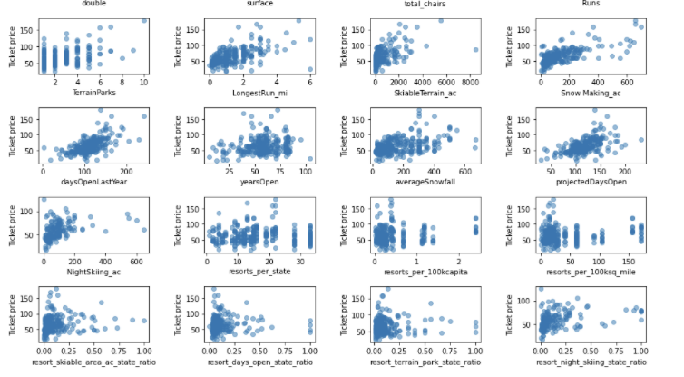

**Figure 1:** Sample of Scatterplots with variable of interest (x) and its relationship with Weekend ticket price.

**Pre-Processing and Developing the Model**:

After data wrangling and EDA, we subsequently explored several model possibilities to see which features would affect weekend ticket prices. We started by simply using the mean as a best guess, then explored the linear regression model and the Random Forest Model. Ultimately, the latter proved the most effective at minimizing the mean absolute error to model what should be the optimal ticket price, and thus we chose this model to determine which key features influenced weekend ticket prices.

**Modelling Results and Key findings:**

The model found that there were 8 variables which primarily influenced our key variable of interest (Figure 2). These were Vertical Drop, Snow Making, Total Chairs, Fast Quads, Runs, Longest Run, Trams and Skiable Terrain. With these variables as the main features, our model was able to predict the optimal price with a Mean Absolute error of $9.

**Figure 2**: Variables which had the largest influence on Weekend ticket prices.

With respects to the scenarios which were proposed by management:

**Scenario 1** – *Closing up to 10 runs:* Closing runs could lead to reducing ticket prices (Figure 3). Optimally, if we are going to close 3, we should close 5 as it would not lead to a further reduction in ticket prices but would reduce operations costs of 2 additional runs. This scenario is to be explored with future operation cost data.

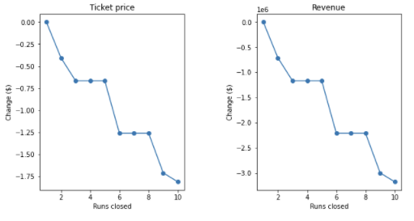

**Figure 3**: Modelled relationship between *Run-Closing* on changes in *Ticket Price* and *Revenue*.

**Scenario 2** – *Adding a Chairlift + Increasing Vertical Drop*: This scenario would support an increase of ticket prices of $1.99 and could generate an additional $3.4 million in revenue. This scenario would be recommended.

**Scenario 3** – *Scenario 2 + 2 acres of Snow Making*: This scenario would have the same effect as scenario 2 but would require investing more resources for snow making for no additional benefits. This scenario is to be avoided in favor of scenario 2.

**Scenario 4** – *Increasing the longest run + Increasing Snow Coverage:* This scenario does not support a ticket price increase and would have no impact on revenue. However, resources would be spent to increase operating cost. This scenario is thus no recommended.

**Conclusion and Future Work:**

In conclusion, the model built supports pricing BM’s tickets closer to $95 than the current $81 as its available features are amongst the top of resorts (Figure4). The evidence is further supported with the mean absolute error being $9. At the very minimum, BM should no reason to be concerned to raise their ticket prices to at least $86. With respects to the scenarios proposed by management, the data model supports opting for Scenario 2, with a possibility to explore Scenario 1 if additional information on operations cost is available. In addition to obtaining data on operations cost, for future analysis, to get better results, we would like to include data for customer preferences as well as evaluating elasticity of demand.

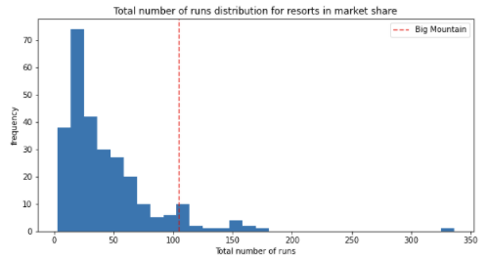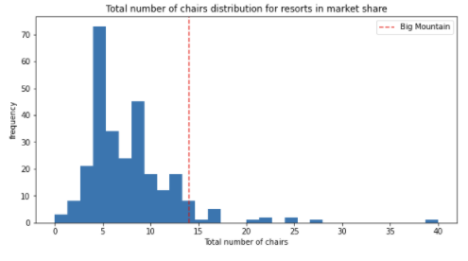

**Figure 4**: Sample of BM’s features relative to its competitors.